1.INTRODUCTION

1.1 overview

Our Team Project is TRAVELTRAX TOURS. Travel refers to the act of moving from one location to another. This can refer to long-distance, short-distance, overseas, domestic, and various other forms. Crucially, travel also includes both round trips and one-way journeys, and it covers a wide variety of different travel purposes.

1.2 purpose

Travel can serve many different purposes, from relaxation and escape from our daily life, to finding the thrill in adventure. You can also use travel as an educational tool, for cultural exploration and learning experiences. Travel is a gift of adventure, discovery, and thrill and I never want it to end.

2.PROBLEM DEFINITIONS & DESIGN THINKING

2.1empathy map

EMPATHY MAP:

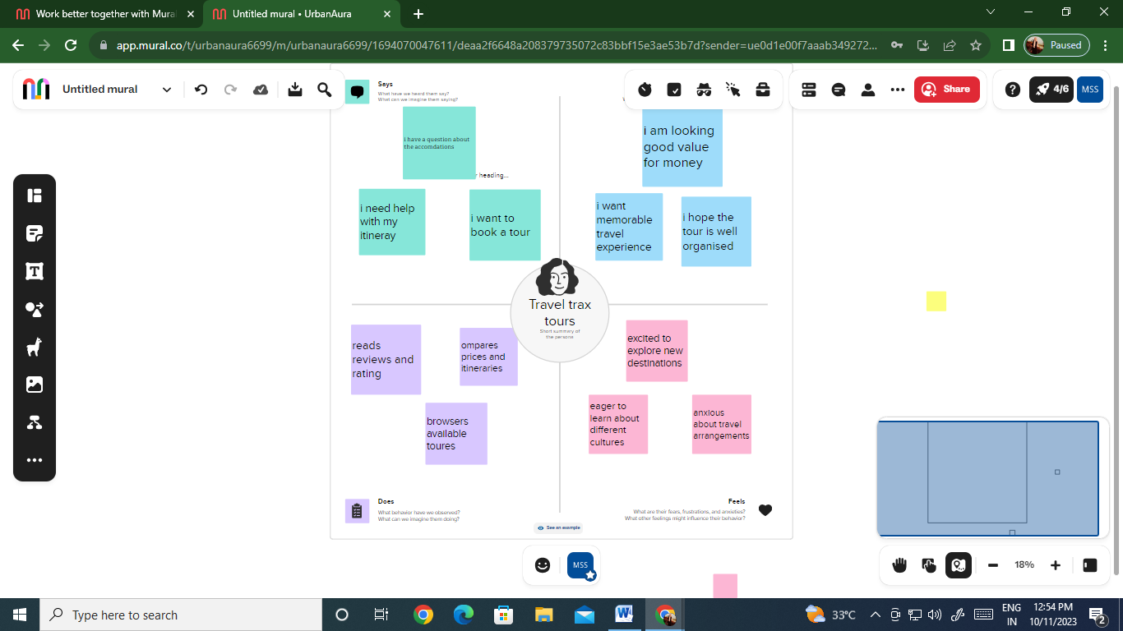

2.2 ideation &brainstorming map

BRAINSTORMING MAP:

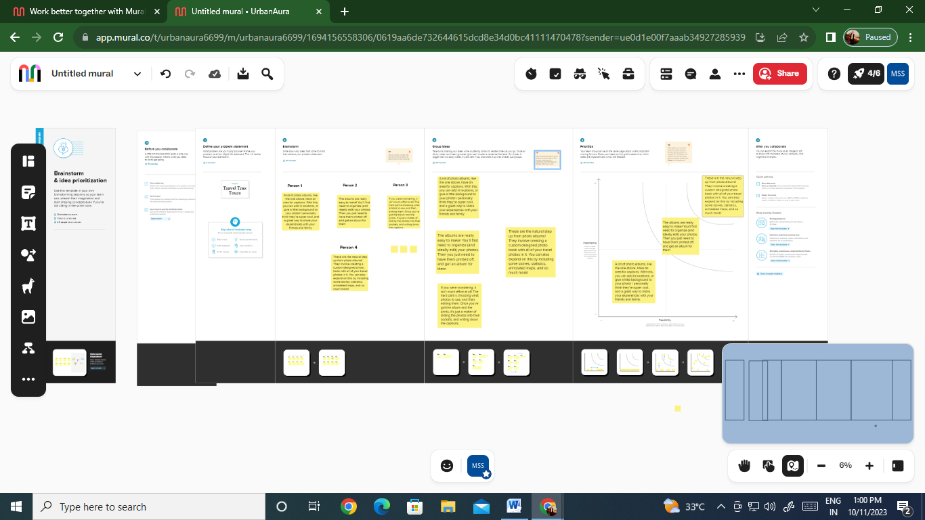

3.RESULT

According to this project the Travel and tourism GDP is predicted to grow and the Revenue in the Travel & Tourism market is projected as profit

PROFIT AND LOSS:

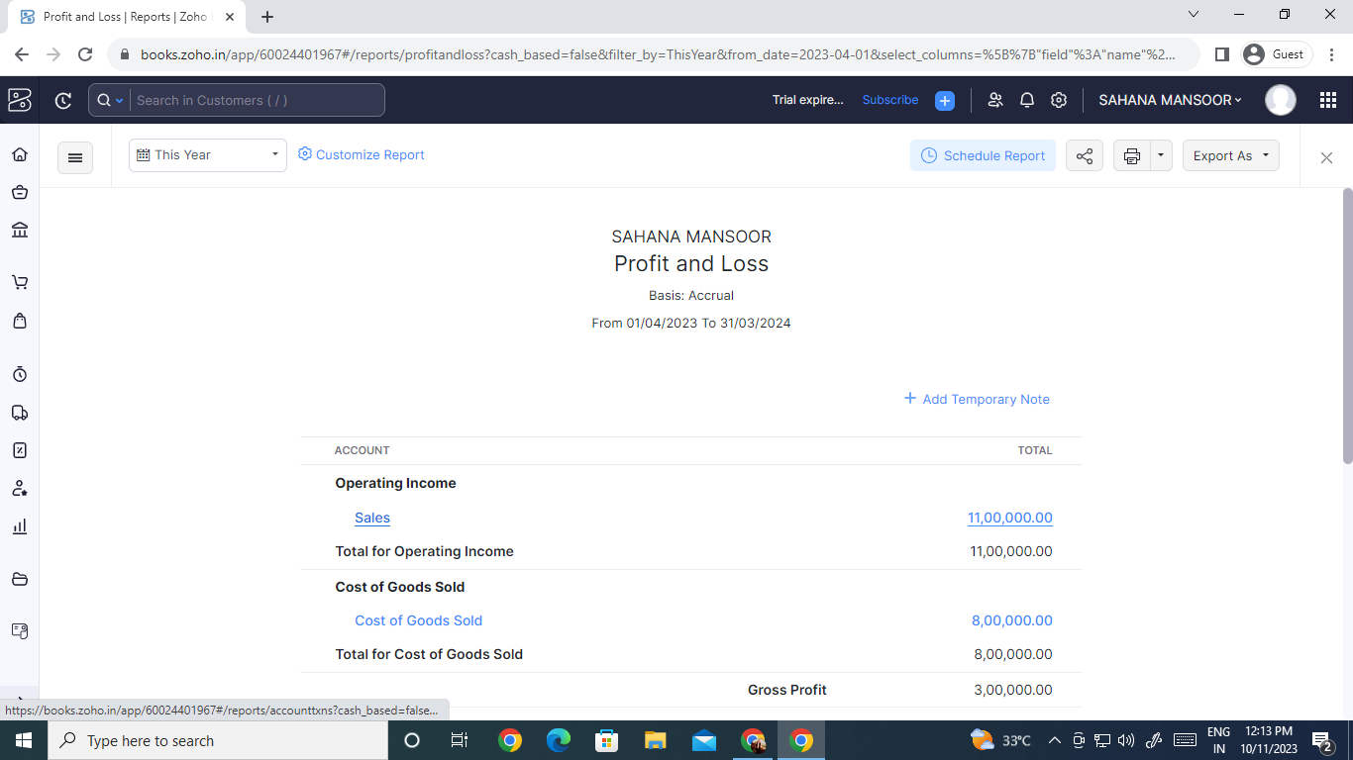

BALANCE SHEET:

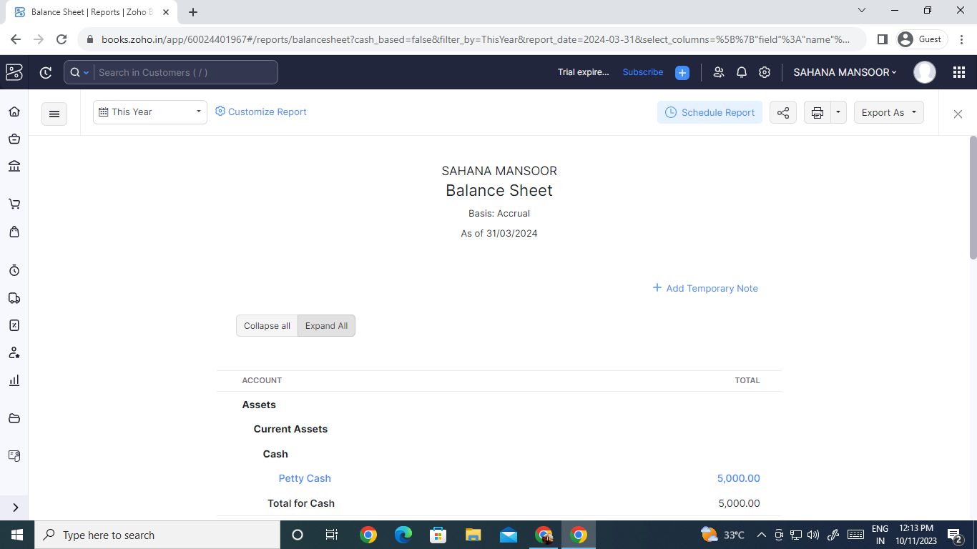

4.ADVANTAGES &DISADVANTAGES

ADVANTAGES

A typical tour package will usually include plenty of destinations. Chances are that going to all these places on your own would cost a lot more, mainly because travel agents and tourism companies have good connections with the hotels and transportation companies, and also because they get maximum discounts for sending groups rather than individuals or single families. One of the biggest advantages is of course the convenience. As earlier suggested, planning for a full-fledged trip and visiting various places will take quite a lot of planning and due diligence. But when you opt for a tour package, you can just sit back and relax — at least as far as planning is concerned.

DISADVANTAGES

The biggest disadvantage of a tour package is the lack of control. You need to follow the guidelines and a strict schedule. You cannot extend your stay in a certain place even if you love it. Similarly you cannot move to the next place if there’s nothing to be excited about, before the scheduled time.

You need to be extra careful while choosing one of these packages. The aforementioned advantages can easily turn into disadvantages if you don’t choose the right company.

You will have to be a little flexible with your dates and timings, in case you are looking to leave and arrive back on certain dates. You might find it hard to find an appropriate trip with the same time frame.

5.APPLICATIONS

TRAVELTRAX TOURS (HOSPITALITY AND TOURISM-INDUSTRY)

6.CONCLUSION

travel and tourism have significantly shaped the global economy and brought people together from different cultures and backgrounds and the Project closure conveys to every group member that the endeavor was worthwhile and that the task is done.

7.FUTURE SCOPE

The global travel and tourism sector's post-pandemic recovery is gaining pace as the world's pent-up desire for travel rekindles. The difference in international tourist arrivals in January 2021 and a similar period in January 2022 was as much as the growth in all of 2021.

Travel and tourism GDP is predicted to grow, on average, at 5.8 percent a year between 2022 and 2032, outpacing the growth of the overall economy at an expected 2.7 percent a year. 5. So, is it all systems go for travel and tourism? Not really. The industry continues to face a prolonged and widespread labor shortage.